USER INTERFACE DESIGN
EXPERIEMENT 3
NAME:ARUNPRANESH ES ROLL NO:240701051

1.Command Line Interface
import random
number = random.randint(1, 10)
guess = int(input("Guess a number between 1 and 10: "))
if guess == number:
print("Correct! 🎉")
else:
print("Wrong ❌ The number was:", number)

OUTPUT:
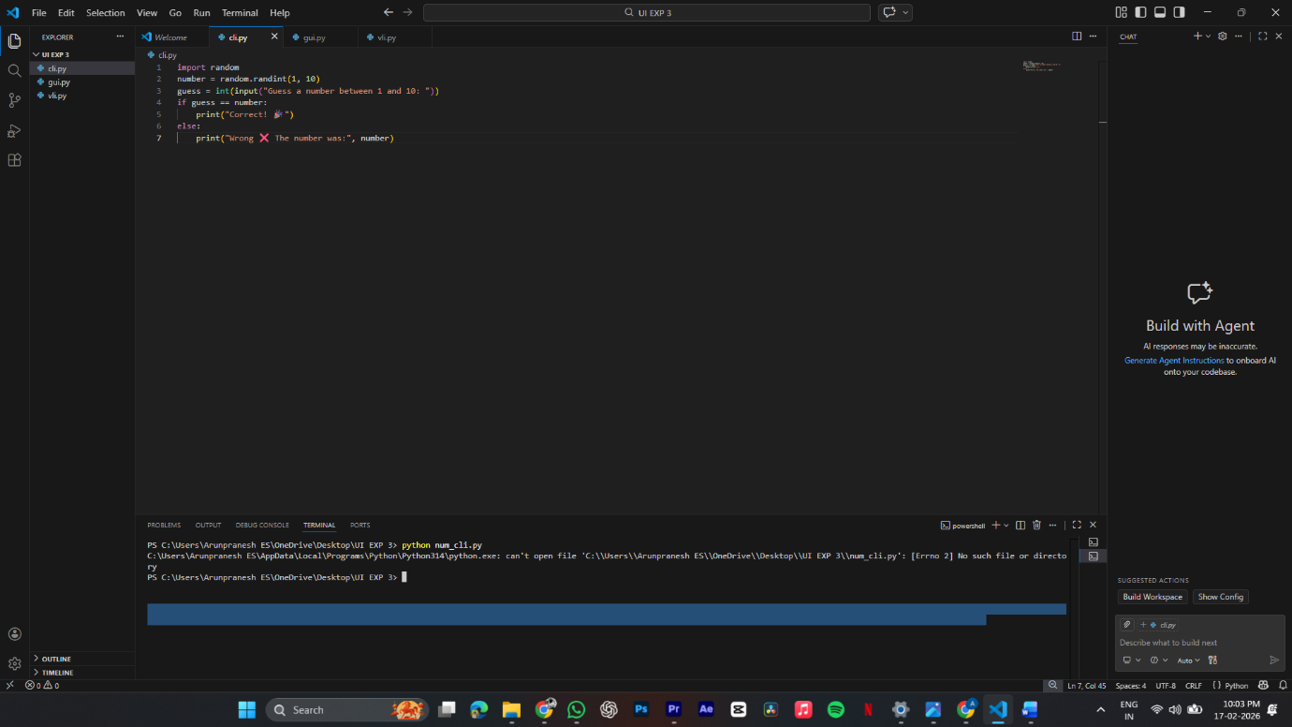

2.Graphical User Interface
import tkinter as tk
import random
from tkinter import messagebox
number = random.randint(1, 10)
def check():
if entry.get().isdigit():
g = int(entry.get())
if g == number:
messagebox.showinfo("Result", "Correct! 🎉")
else:
messagebox.showinfo("Result", f"Wrong ❌ Number was {number}")
else:
messagebox.showwarning("Error", "Enter a number!")
root = tk.Tk()
root.title("Guess Game")
root.geometry("300x200")
tk.Label(root, text="Guess 1 to 10").pack(pady=10)
entry = tk.Entry(root)
entry.pack()
tk.Button(root, text="Check", command=check).pack(pady=10)
root.mainloop()
OUTPUT:

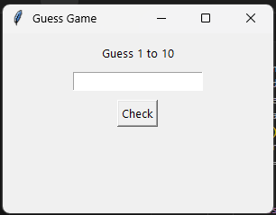
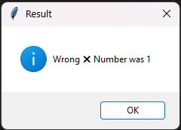
3.Voice User Interface
import random
import time
secret = random.randint(1, 20)
print("🎙️ Voice User Interface Activated")
time.sleep(0.5)
print("🔊 System: I am thinking of a number between 1 and 20")
time.sleep(0.5)
print("🔊 System: Please say your guess")
while True:
guess = input("\n🎤 You: ")
print("🎧 Processing your voice input...")
time.sleep(0.5)
if not guess.isdigit():
print("🔊 System: Please say a valid number")
continue
guess = int(guess)
if guess < secret:
print("🔊 System: Too low. Try again")
elif guess > secret:
print("🔊 System: Too high. Try again")
else:
print("🎉 🔊 System: Correct! You guessed the number")
break
OUTPUT:
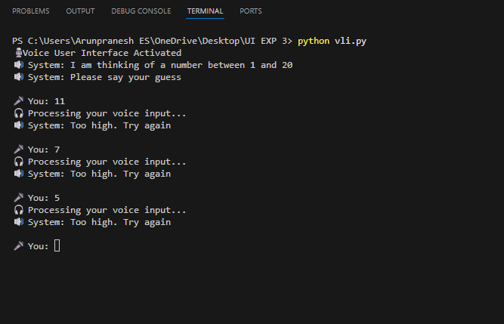

4.User Satisfaction Comparison
print("📊 User Satisfaction Comparison")
print("Rate each interface from 1 (Very Poor) to 5 (Excellent)")
print("-" * 45)
cli = int(input("💻 Rate CLI (1-5): "))
gui = int(input("🖥️ Rate GUI (1-5): "))
vui = int(input("🎤 Rate VUI (1-5): "))
average = (cli + gui + vui) / 3
print("\n📈 Final Ratings Summary")
print("-" * 45)
print(f"💻 CLI Rating : {cli}/5")
print(f"🖥️ GUI Rating : {gui}/5")
print(f"🎤 VUI Rating : {vui}/5")
print("-" * 45)
print(f"⭐ Average User Satisfaction : {average:.2f}/5")
print("\n🧠 Interpretation:")
if average >= 4:
print("Users are highly satisfied with the interfaces 👍")
elif average >= 3:
print("Users are moderately satisfied 🙂")
else:
print("User satisfaction needs improvement ⚠️")

OUTPUT:
